Operating Systems Lab Sheet 5

Jack Carroll

T00194823

Under the System Summary heading locate and list the following:

Processor: Intel® Core™ i7-4770

BIOS Version/Date: Dell Inc. A07, 25/04/2014

Total Physical Memory: 7.94GB

Under the Hardware Resources heading locate and list the following:

DMA channels and the device using the resources.

Channel 4, Direct memory access controller

I/O address range for these devices:

Printer Port (LPT1): N/A

Communications Port (COM1): 0x000003F8-0x000003FF

Communications Port (COM2): N/A

IRQ address for these devices:

System timer: IRQ 0

Communications Port (COM1): IRQ 4

Communications Port (COM2): N/A

Under the Components heading and Software heading look around to see what information is provided in these areas.: Components = Multimedia,Input,Network,Ports,Storage

Software = System Drivers, Print Jobs, Network Connections, Running Tasks, Windows Error Reporting

Close the System Information window.

Open **System Configuration** by clicking **Start > Run >** type **msconfig OR** Click **Start>Control Panel>System Configuration**

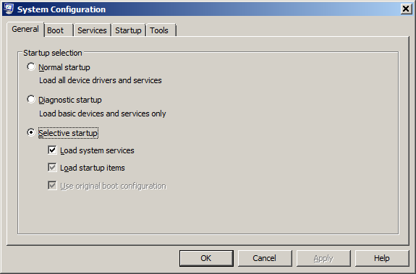

Click the **General** tab if it is not already active.

What are the startup options? : Normal Startup, Diagnostic Startup, Selective Startup

Click the **Boot** tab. This tab is for modifying boot options.

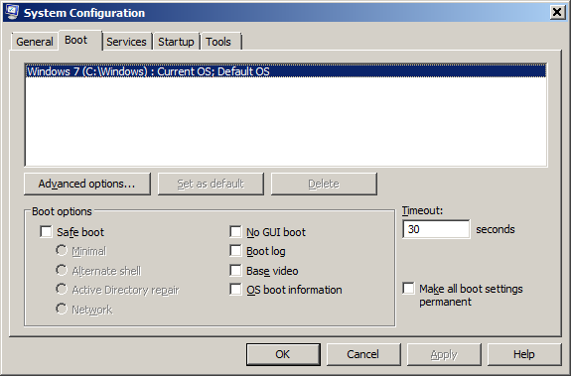

Click the **Services** tab. This tab lists the computers services and there status.

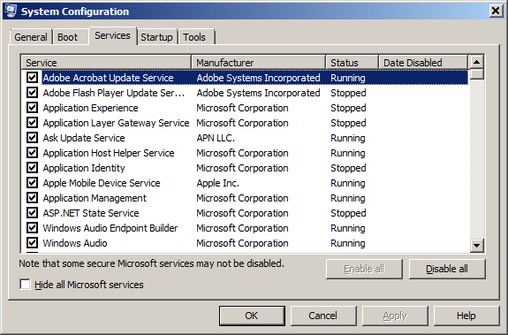

Can you enable and disable services at this tab? Yes

Click the **Startup** tab. This tab lists the programs that are automatically loaded every time you turn on your computer.

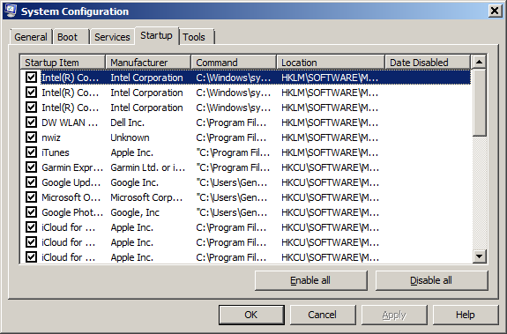

Click the **Tools** tab.

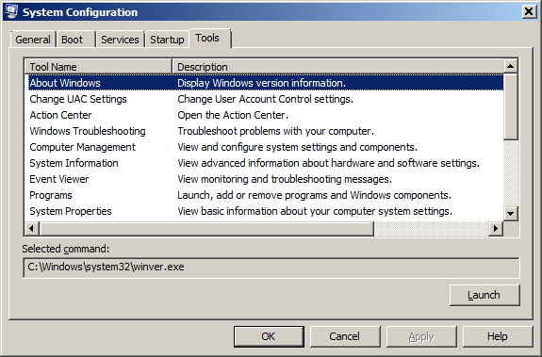

**Examine what can you do by launching the different applications? Take Screenshots.**

Action Center